Shrinkage correlation: USDJPY and USDCAD
Method 08 / eight-major panel / delta = 0.2 and Ledoit-Wolf / Alpari D1 full available history

Study setup
Logical pair: USDJPY , USDCAD
Broker symbols: USDJPY_i , USDCAD_i
Snapshot: 2026-11-03_majors_alpari_D1
Timeframe: D1
Common eight-major panel window: 1999-01-06 to 2026-11-02 (UTC bar dates)
Panel matched return count n: 7127
Dropped unfinished last bar dated 2026-11-03 UTC after a tick-volume check against the prior complete day.
Fixed shrinkage: delta=0.2, mu=3.9170889e-05 (mean of diag(S))
Ledoit-Wolf estimated delta: 0.0042157642
Panel symbols: EURUSD, GBPUSD, AUDUSD, NZDUSD, USDJPY, USDCHF, USDCAD, EURGBP
Complete matched rows (Excel): USDJPY-USDCAD_Shrinkage_D1.xlsx
Complete matched rows (HTML table): USDJPY-USDCAD_Shrinkage_D1_data.html

Method carried forward
Shrinkage blends the sample covariance matrix S of matched daily log returns of close, ln(close_t / close_t-1), toward a simple target, then converts the shrunk covariance into correlations. Quotes are not inverted. This experiment builds one common calendar across all eight majors, forms S with the unbiased n-1 divisor, then reports two shrinkage specs: fixed delta = 0.2 with mu equal to the average sample variance (mu * I target), and sklearn Ledoit-Wolf with its estimated delta. Pair reports pull rho_ij from those panel matrices. Same-panel Pearson r is a side check only. Shrinkage improves conditioning; it is not a cause, not a lead, and not a trading signal.

Results
pearson_r | rho_02 | rho_LW | rho_02_minus_r | rho_LW_minus_r | delta_LW
0.026272 | 0.02005 | 0.026134 | -0.006223 | -0.000138 | 0.00421576

Conclusion
Over the common 7127-day eight-major panel for USDJPY and USDCAD (broker quote directions unchanged), fixed-delta shrinkage correlation at delta=0.2 is 0.0200 (positive, weak linear link in this sample). Ledoit-Wolf rho is 0.0261 with estimated delta=0.004216. Same-panel Pearson r is 0.0263 (rho_02 minus r = -0.0062; rho_LW minus r = -0.0001). This does not establish cause, lead-lag, or a lasting trading rule.

Charts
Daily closes
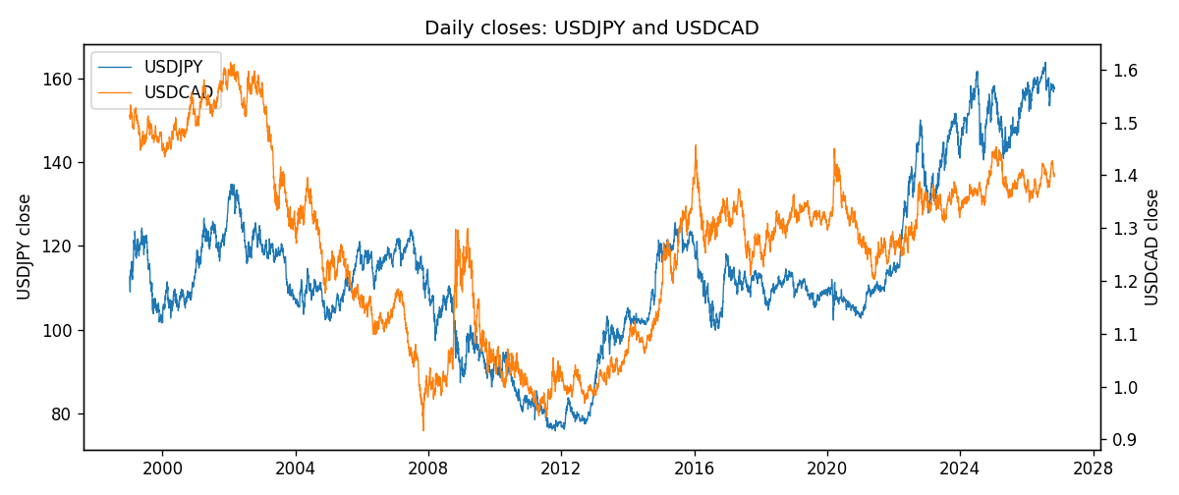
Daily log returns
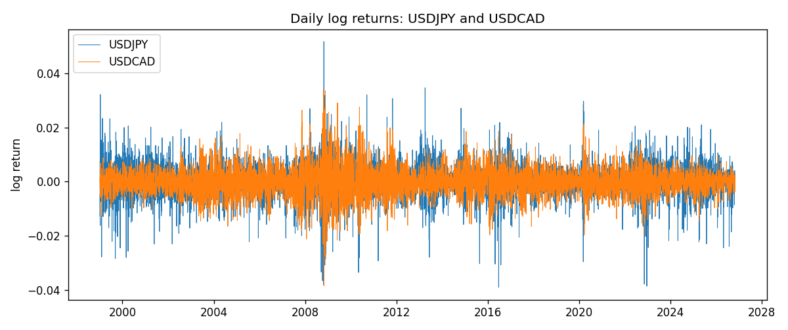
Log-return scatter
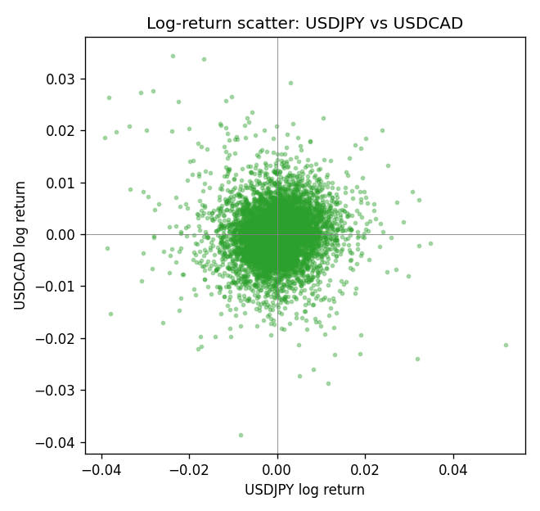

Data report
Every panel row for this pair slice is stored in the sibling Excel workbook named USDJPY-USDCAD_Shrinkage_D1.xlsx. Full-panel covariance and correlation matrices are saved once under outputs/ as CSV files. Embedding all rows as a Word table is impractical at this length; the Word file holds the column list, column summaries, and the first and last 15 matched rows.
Columns: time, USDJPY_open, USDJPY_high, USDJPY_low, USDJPY_close, USDJPY_tick_volume, USDJPY_spread, USDJPY_real_volume, USDJPY_log_return, USDCAD_open, USDCAD_high, USDCAD_low, USDCAD_close, USDCAD_tick_volume, USDCAD_spread, USDCAD_real_volume, USDCAD_log_return
Column summaries (panel rows)
column | count | mean | std | min | 25% | 50% | 75% | max
USDJPY_open | 7127 | 113.80058 | 19.291864 | 75.693 | 104.3005 | 110.961 | 120.7475 | 163.824
USDJPY_high | 7127 | 114.29785 | 19.353625 | 76.001 | 104.822 | 111.42 | 121.29 | 163.978
USDJPY_low | 7127 | 113.2782 | 19.219415 | 75.402 | 103.814 | 110.515 | 120.2 | 163.628
USDJPY_close | 7127 | 113.81424 | 19.307121 | 75.811 | 104.298 | 110.98 | 120.725 | 163.851
USDJPY_tick_volume | 7127 | 107141.8 | 179947.68 | 197 | 10056 | 53577 | 93233 | 1803508
USDJPY_spread | 7127 | 20.095973 | 17.5534 | 0 | 6 | 11 | 30 | 50
USDJPY_real_volume | 7127 | 3.5056645e+10 | 1.6155964e+11 | 0 | 0 | 0 | 0 | 3.8834203e+12
USDJPY_log_return | 7127 | 5.336e-05 | 0.00621278 | -0.03908203 | -0.00319557 | 0.00013026 | 0.00340928 | 0.05184024
USDCAD_open | 7127 | 1.2660158 | 0.16869092 | 0.9168 | 1.11698 | 1.29814 | 1.371685 | 1.6183
USDCAD_high | 7127 | 1.2709144 | 0.16864061 | 0.9336 | 1.122275 | 1.30368 | 1.37575 | 1.619
USDCAD_low | 7127 | 1.2614634 | 0.1687284 | 0.9056 | 1.112315 | 1.29315 | 1.36729 | 1.6102
USDCAD_close | 7127 | 1.2660395 | 0.16866578 | 0.916 | 1.116855 | 1.298 | 1.371955 | 1.6137
USDCAD_tick_volume | 7127 | 81672.889 | 147760.33 | 56 | 5669.5 | 41299 | 71973 | 1410818
USDCAD_spread | 7127 | 23.249895 | 18.19595 | 0 | 9 | 17 | 40 | 60
USDCAD_real_volume | 7127 | 1.8530805e+10 | 9.7086285e+10 | 0 | 0 | 0 | 0 | 2.5751613e+12
USDCAD_log_return | 7127 | -7.67e-06 | 0.00514753 | -0.03859748 | -0.0028338 | 5.597e-05 | 0.00272861 | 0.03436319
First 15 panel rows (selected columns)
time | USDJPY_close | USDCAD_close | USDJPY_log_return | USDCAD_log_return
1999-01-06 | 112.77 | 1.5118 | 0.0075660159 | -0.0003306769
1999-01-07 | 111.33 | 1.5141 | -0.012851583 | 0.0015202092
1999-01-08 | 110.8 | 1.511 | -0.0047719894 | -0.0020495197
1999-01-11 | 109.02 | 1.5057 | -0.016195423 | -0.0035137769
1999-01-12 | 112.6 | 1.5157 | 0.032310364 | 0.0066194721
1999-01-13 | 113.52 | 1.5226 | 0.0081373171 | 0.0045420214
1999-01-14 | 113.52 | 1.5332 | 0 | 0.0069376546
1999-01-15 | 114.15 | 1.5245 | 0.0055343401 | -0.0056905671
1999-01-18 | 114.16 | 1.526 | 8.7600193e-05 | 0.00098344542
1999-01-19 | 113.52 | 1.5302 | -0.0056219403 | 0.002748513
1999-01-20 | 112.91 | 1.5211 | -0.0053879917 | -0.0059646885
1999-01-21 | 113.87 | 1.5146 | 0.0084664056 | -0.0042823796
1999-01-22 | 114.56 | 1.5184 | 0.0060412564 | 0.0025057712
1999-01-25 | 113.72 | 1.5197 | -0.0073594164 | 0.00085579808
1999-01-26 | 113.86 | 1.52 | 0.0012303367 | 0.0001973879
Last 15 panel rows (selected columns)
time | USDJPY_close | USDCAD_close | USDJPY_log_return | USDCAD_log_return
2026-10-13 | 158.305 | 1.4214 | -0.0018932826 | -0.0046395653
2026-10-14 | 158.317 | 1.42356 | 7.5800166e-05 | 0.0015184751
2026-10-15 | 158.024 | 1.41843 | -0.0018524319 | -0.0036101503
2026-10-16 | 157.964 | 1.41357 | -0.00037976126 | -0.0034322068
2026-10-19 | 158.517 | 1.41091 | 0.0034946841 | -0.0018835331
2026-10-20 | 158.16 | 1.40569 | -0.0022546642 | -0.0037066008
2026-10-21 | 158.108 | 1.4045 | -0.00032883504 | -0.00084691787
2026-10-22 | 156.755 | 1.40081 | -0.0085942669 | -0.0026307268
2026-10-23 | 156.81 | 1.40085 | 0.00035080446 | 2.85545e-05
2026-10-26 | 157.458 | 1.40093 | 0.0041238746 | 5.7106554e-05
2026-10-27 | 157.894 | 1.40449 | 0.0027651658 | 0.0025379458
2026-10-28 | 157.743 | 1.39911 | -0.00095679538 | -0.0038379274
2026-10-29 | 157.683 | 1.39895 | -0.00038043789 | -0.00011436495
2026-10-30 | 157.516 | 1.39751 | -0.0010596481 | -0.0010298736
2026-11-02 | 157.933 | 1.39837 | 0.0026438521 | 0.00061519094

